<https://github.com/swairik/Antwalk-Assignments/tree/main/JSP%20%26%20Hibernate/Assignment1%20-%20Hibernate>

1. 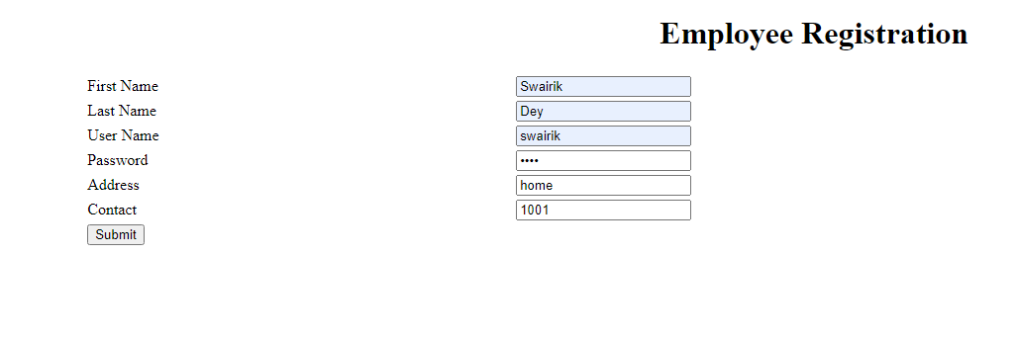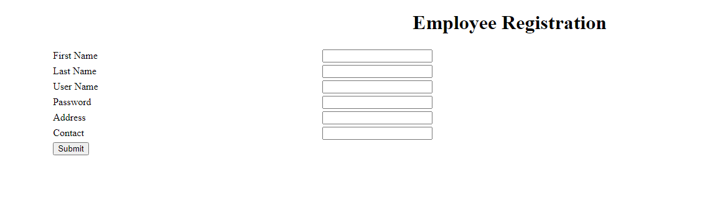MVC Project



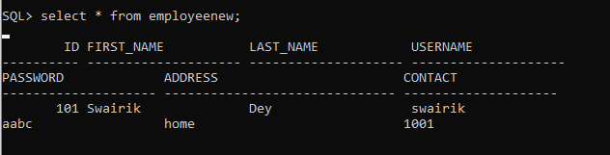

EmployeeServlet.java

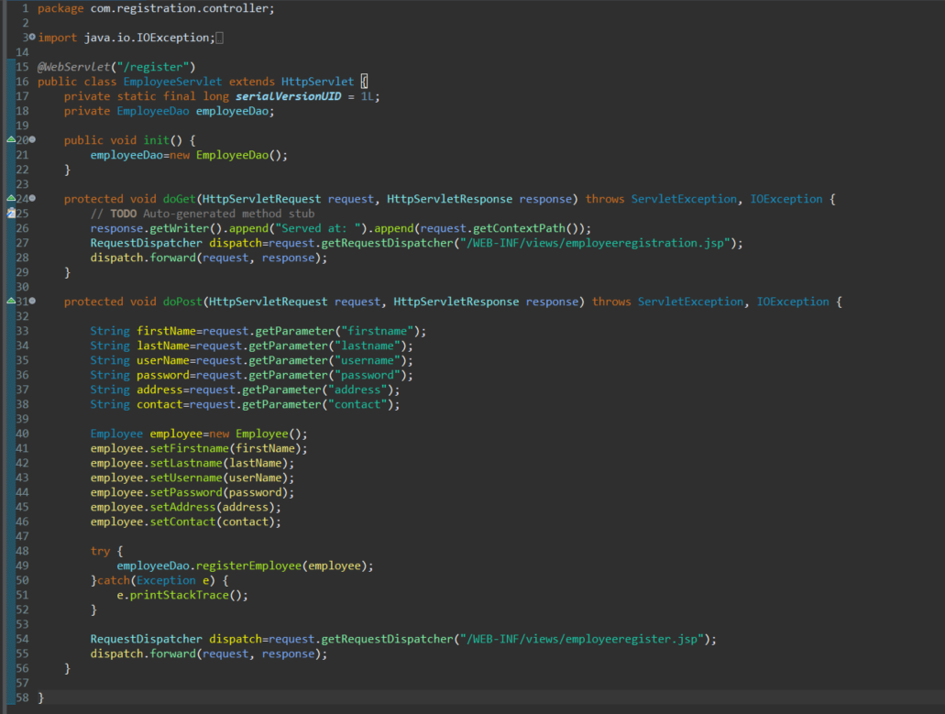

EmployeeDao.java

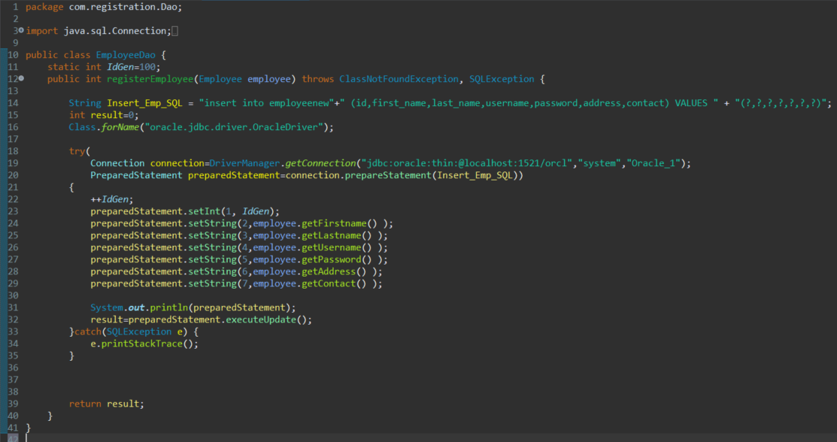

1. CRUD Project

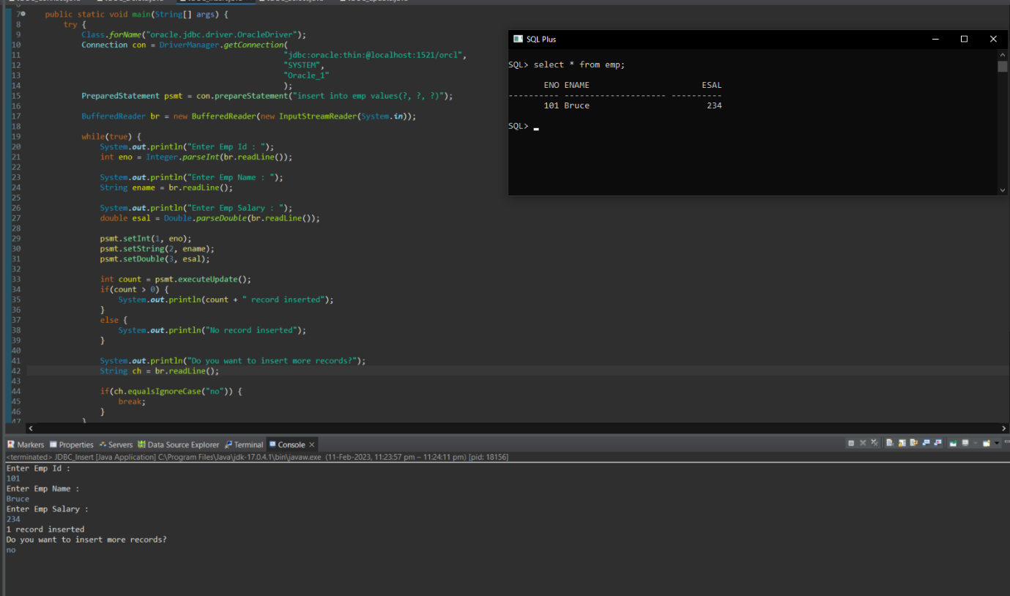Create Operation

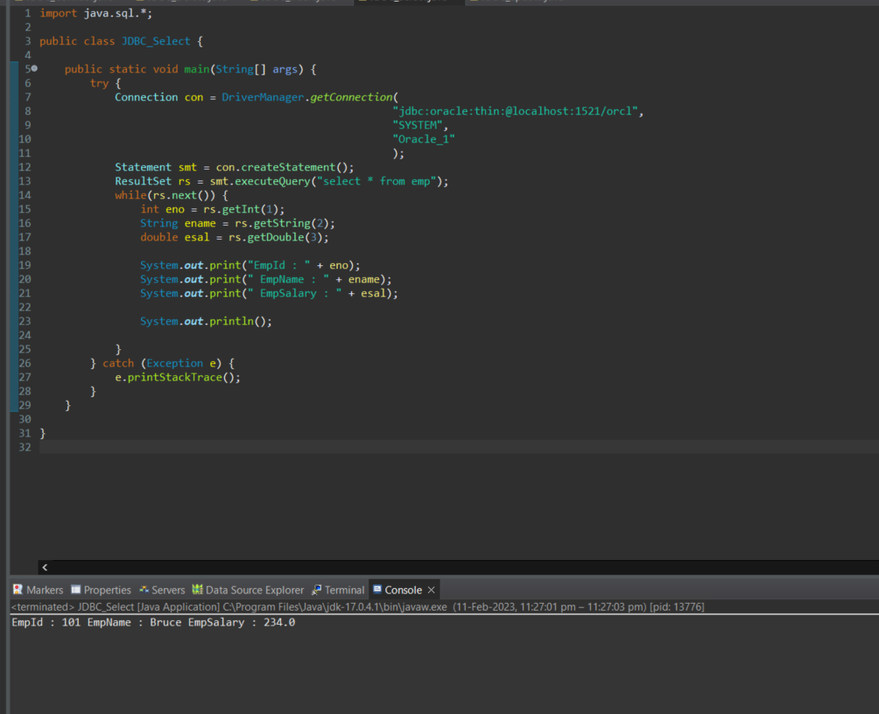Read Operation

Update Operation:

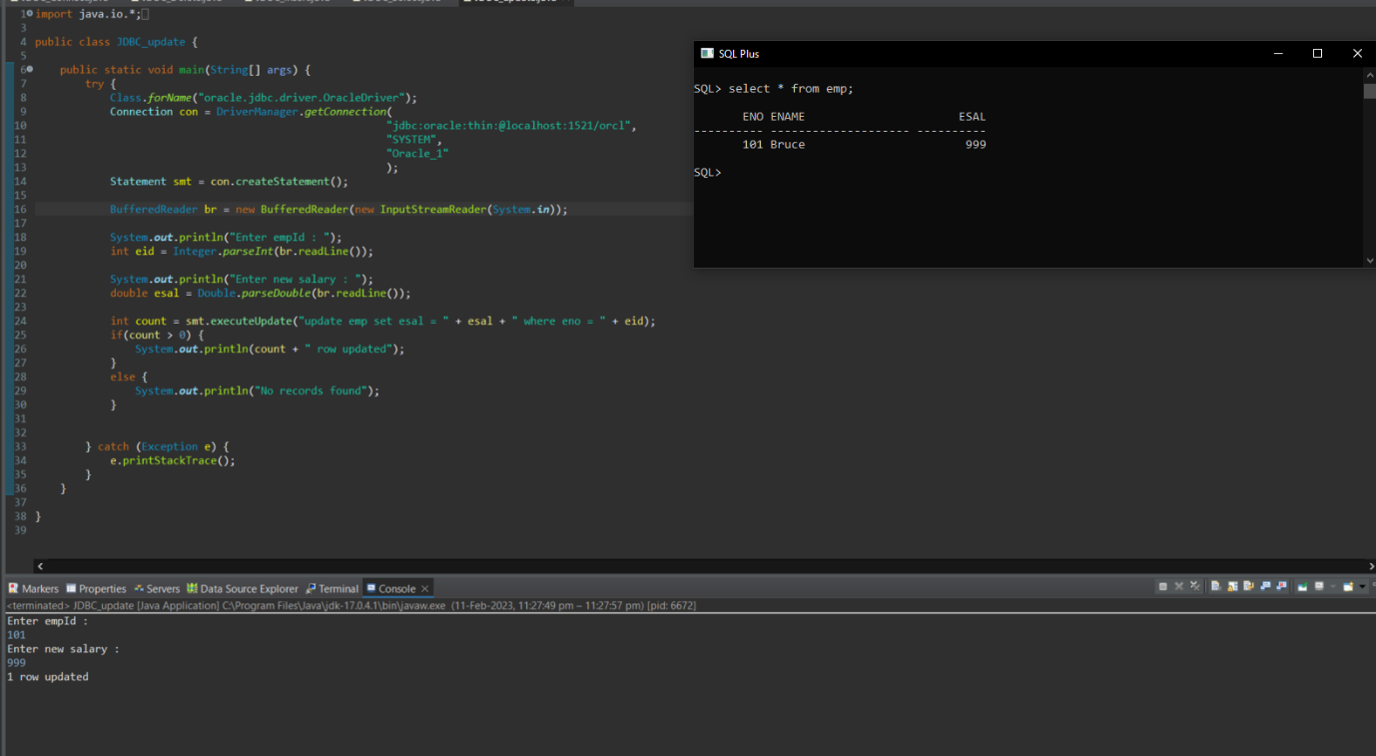

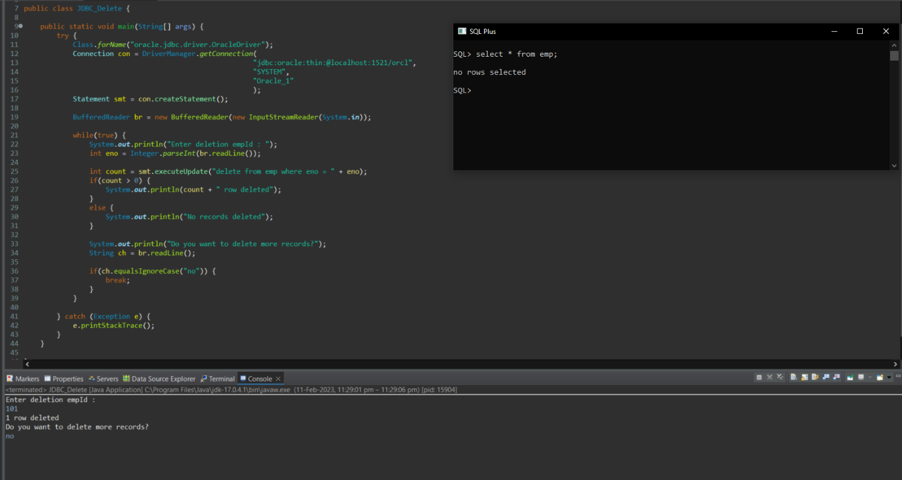Delete Operation :